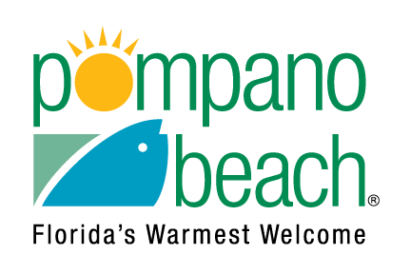

**FREE JOB FAIR REGISTRATION FORM FOR THURSDAY, OCTOBER 28, 2021**

Name of Company:

Contact Name:

Contact Email:

Address of Company:

Telephone:

Website:

Brief Description of Company:

Resource Organization (Resource You Plan to Provide):

Number of Staff Attending:

Employer - Number of Job Openings:

Types Employment (Full / Part time):

Open Positions / Job Title / Description:

Salary Range:

Do you need access to power outlets?

May we use your company name on our advertising?

Would you like to be placed on our e-mail list?

**If you have any questions, please contact 954-786-7866. Please return the completed form to** [**dahlia.baker@copbfl.com**](mailto:dahlia.baker@copbfl.com) **or fax to 954-786-7836 or mail to Pompano Beach CRA, 100 West Atlantic Blvd., Room 276, Pompano Beach, FL 33060.**